Making a BrisLETS Promo
IN THIS ISSUE

Making a BrisLETS Promo
November Trading Day
InterLETS
LETS Will
Andrews contribution
Sept Trading Day
New Members
CES update

This Trading Day
Sun 21st November 2021
Albion Peace Hall
1-4pm,
Following Trading Day
February
Sun 20th February 2021
Albion Peace Hall

Deadlines

NewsLETS stories, notices, advertising and reports:
Sun 5th February 2022

for publication on
Sun 13th February 2022

Edition by Jessie Scott
BrisLETS’ monthly roundup of events, achievements, and plans.

BLCE NewsLETS November 2021
New member Rebekah BLCE 1437 has responded to Michael’s suggestion to make a promo to explain and motivate members to join BrisLETS.

Based on her experience, individual members capturing moments that express what LETS means to them, on their phone, then editing them together, is much more authentic! We can use these induvial bits of video to create a 2-10 min promo that can be stored in YouTube and linked to stories without using the available storage, and as well as in bites on social media.

We need a script (and I know we have very talented members who hopefully can contribute to this), to establish a goal of the promo, style video etc. The www.canva.com free membership might be enough to do the promo. Social media presence of BrisLETS would be key to utilising the promo, and skilling members up would be needed if we can’t attract skilled members.

So we have very creative outside the box thinkers in this very diverse group – what quick video could you take on your phone that explains what you think makes LETS unique? What makes you value LETS? What you love and get joy from being in LETS?

When a situation happens unexpectedly that would be perfect, having a plan on how to do it and practicing it will help us take advantage of special opportunities! Please be AWARE – it’s unsafe for some members to be in photos – please ask if you have taken a photo / video at the trading day and delete it if they say no!
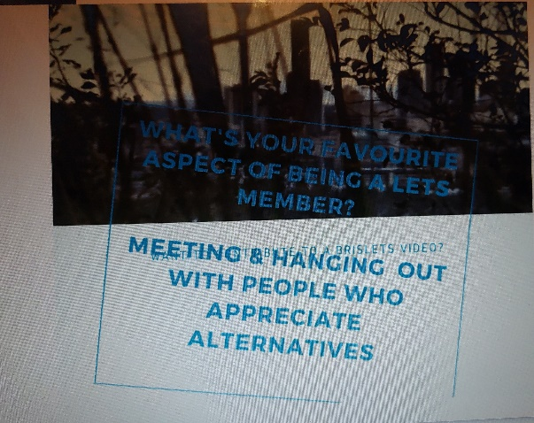
Rebekah also created a document in google (links in Members Forum) for people to fill in what they would like to be involved in – or if not tech savy, let Jessie know via email or mobile text please so she can add you.

Rebekah created a quick example for you here.

Pre Xmas Mega Market Extravaganza.

Join us for breakfast tomorrow! These twice a year interlets events are so much fun. We generate a lot of LETS units.

Please come along and support this trade event by either having a stall or buy items others bring. Over continental breakfast, cakes, tea and coffee provided for a small $ and units fee, we could share ideas on how to support each other in LETS or in the community.

Saturday 13th of November 2021
From 9am (set up from 8 am) till about 12-1pm-ish
Maleny Neighbourhood Centre
17 Bicentenary Lane Maleny

For catering purposes, RSVP would be appreciated.

We hope to see many members attending.

Happy trading
Anika
South East Queensland LETS

November Trading Day Sunday 21st

This will be our last Trading Day of the year.

With our festive season upon us, it’s an
excellent time to plan a stall or share with
others to add value to things you have or
extras you don’t want – plants, items, craft,
repurposing and recycling.

Albion Peace Hall this Sunday 1-4pm. Sally is opening and closing.

We will resume our Trading Days on 20th February 2022 at the
Albion Peace Hall, 3rd Sunday of the Month 1-4pm.

Jessie is giving notice for next AGM – Brislets needs a new secretary, newsletter content writer & editor, website content writer & admin, photographer, promotions, & CES admin

I am really struggling to do anything these days mentally and physically so need time out of my community activities.
Family needs is taking up a lot of time.

Since there is quite a bit involved in those roles, please indicate your interest so you have time to learn the role and help develop the checklists so anyone can do them in the future.

CES News Update
Rita is the new admin
person for Australia.
https://www.communityexchange.net.au

Workcover Insurance
$50 for 2 years to cover
individuals working in your
house. Phone 1300 362 128 or
https://ols.workcoverqld.com.au/ols/public/newbusiness

LETS Will
Members could have noted in their CES account in Admin Notes, their next of kin name, address, ph number & email address & what they want done with their credits should they pass.
A sort of 'LETS will' so that the Admin can make the changes to the LETS account when the time comes.

Years ago in another LETSystem, Admin hadn't had replies to their emails from one member. Admin rang & found out she had died. Her partner gave instructions for her account to close, balance to transfer etc etc.
A couple of us have had Will instructions written in our accounts (in Notes).
Only the Admin is able to type in the Notes field so members need to send the instructions to Admin via email to add to the account notes.
DEBIT and CREDIT Limits
In the BrisLETS CES exchange there are account balance limits, ours are currently set at 2000 for both Credit and Debit balances for all accounts. If we examine the account balances on our exchange we can see that most people's accounts are within this range.
According to the CES guidelines the aim of the game is for your account to hover around a zero balance. When your account is in CREDIT it means that you have received more units than you have spent (giver), conversely when you have a DEBIT balance you have spent more than you have earned (taker). Yet we see balances over these limits, (we also see deactivated accounts with Credit and Debit balances - more on this later in another article).

As this is an accounting system, what are the implications of this?
Why are these limits set?
In a mutual credit system, money (yes MONEY) is created when it is needed, accounts are debited and credited in a seesaw fashion.

What happens when a limit is reached?
I would postulate that trading stops, until an offer/want is accepted, and the balance is restored to be between the limits.

Here is an interesting interview from May this year with Michael Linton, founder of the LETS system - https://www.youtube.com/watch?v=mlUuDvfrlkg at 20 minutes, one of reasons he says why LETS didn't take off, is because of the 'rules' imposed onto the system.

CREDIT unlimited - Why limit trade if a person is willing to offer their goods and services to the community? If they cannot spend it in the community then the risk is theirs alone.

DEBIT limit - One could argue that debits could also be unlimited as Michael Linton does, however as explained here - https://wiki.p2pfoundation.net/LETS there is no incentive for people to return their balance to zero. I guess a question could be, if somebody leaves the system in DEBIT, does it matter? This means that a person has TAKEN from the COMMUNITY without the obligation to GIVE back to the COMMUNITY. I would argue that it does matter, do we want to encourage a community of givers/takers or a community of givers and takers?

As for setting a limit, I think that a 2000u DEBIT limit is appropriate for established members, maybe reduce the DEBIT limit for new members to 200u for 12 months. This way risk is reduced.

PROPOSAL: Remove the CREDIT limit of 2000 units, Introduce a new member DEBIT limit to 200 units for their first 12 months of membership.

Note: New members need to show that they are active in the exchange with CREDIT balances in order for their DEBIT limit to be increased.

Our next topic will be - The Admin account and why it is special?
(A MMT perspective: https://www.investopedia.com/modern-monetary-theory-mmt-4588060)

Written by Andrew G (Blce1498)
– views not reflecting the committee’s.

Items for sale

BLCE1402 Lynette L has moved so has items for sale – contact her for photos or see at the trading day

Desk and matching 2-drawer filing cabinet, 4 sets of tubular plastic shelving, Rocking chair, 2 bedside stands, each with 2 drawer, Bookshelves 1200 Portable glass oven, Cube shelves single cube x 3, Chair-side shallow shelves & magazine rack, Shelf-kit, CPAP mask for small face, Red cast iron soup pot, Curtain hooks, tapes, & fittings, Stirring paddle from beer making kit, Camp stretcher, DVDs and CDs,Small jars with lids, shower head with filter.
Items Wanted
BLCE 0013 Suzanne wants Veg and herb seeds for off grid gardening – would love heirloom if you have any!

Please welcome new members

BLCE1440 Jennifer from Redlcliffee
Offers: household items and supporting creating local LETS in the Redcliffe area – has had good response using the local social media.

BLCE0046 Haydee from Graceville
Offers: Catering, cooking, clothes and tuition.

BLCE37 Rebekah – Art House Digital Media Pty Ltd from Paddingston.
Offers: Videopgraphy, knitting and crocheting from photo

BLCE1449 James from Palm Beach
Offers: Permaculture, gardening
Wants: seedlings, chicken/quail coop and equipment, minor earth works.

September Trading Day hosted by Michael and Isabelle
A great interactive day was experienced by members with Solar cooking, Bamboo weaving to make tunnels etc to protect gardens from brush turkey damage, Michael showed how to get castings from worm farms. Isabelle D made French Pancakes, Isabelle L brought hand made masks etc. Congratulations to the winners of the raffles and thank you to the donors and all those who supported it!
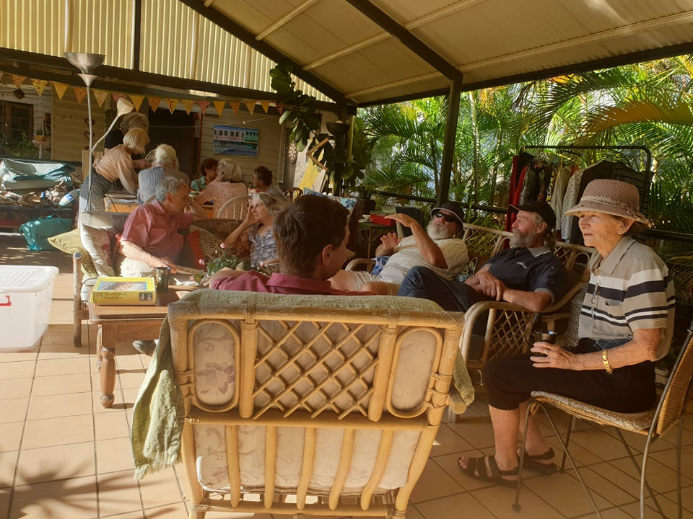

Raffle winners
Lynne G won the massage by Sally
Arcadia won the pearl earrings from Michelle
Russell won coin sorter
Won reading by Kelly
Won journal by Ishka
Won journal by Ishka
Won shoe rack from Jeni

